PSYCHOLOGY 5
MIDTERM EXAM 1
RAY GRIMM, Ph.D
SHOW YOUR WORK and STATCRUNCH TABLES

Name: ________________________________________

- SHOW YOUR WORK
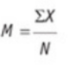=(6*3+5*0+4*9+3*5+2*1+1*1+0)/20=72/20=3.6

SHOW YOUR WORK - MUST USE THE COMPUTATIONAL FORMULA
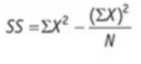
SS=262-3600/15=262-240=22

- ATTACH STATCRUNCH TABLE IN ORDER TO GET CREDIT FOR THIS PROBLEM

- ATTACH STATCRUNCH TABLE IN ORDER TO GET CREDIT FOR THIS PROBLEM

20.SHOW YOUR WORK - MUST USE THE COMPUTATIONAL FORMULA
=3113-2527=586
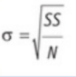
√(586/7=9.15

- SHOW YOUR WORK - MUST USE THE COMPUTATIONAL FORMULA
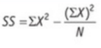=97300-94556.25=2743.75

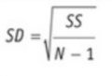=√2743.75/15=13.52

- SHOW YOUR WORK

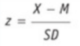= (72-70)/4=0.5
This value in the table corresponds to o.69146=0.6915

- SHOW YOUR WORK
Z for SFT =(62-50)/10=1.2
Z FOR GFT=(120-115)/20=0.25

27. Show your working

Z HIST=(69-70)/14=-0.071
Z COGNITIVE=(65-55)/9=1.111

